**Scope Management Plan**

**Scope Management Plan**

**Travel Advisor Web Application**

**12- April 2022**

**Table of Contents**

Introduction 3

Scope Management Approach 4

Roles and Responsibilities 5

Scope Definition 6

Project Scope Statement 6

Work Breakdown Structure 6

Scope Verification 9

Scope Control 9

Sponsor Acceptance 10

# Introduction

This plan documents the scope management approach; roles and responsibilities as they pertain to project scope; scope definition; verification and control measures; scope change control; and the project’s work breakdown structure. Any project communication which pertains to the project’s scope should adhere to the Scope Management Plan.

This project is for designing, programming, and testing a Travel Advisor Web Application which will be used to help travelers in choosing their future destinations and make them feel like they travel by navigating and browsing the app. This includes the design of the software, all programming and coding, and testing/validation of the software. No external resources or outsourcing are anticipated for this project.

**Project Requirements**:

1. User enter to login registration and login via email and password.
2. Client can navigate through the website through different tours, destinations.
3. Registration form consist of First Name, Last Name, Age, Email, Password.
4. User can book the tour and confirmation email will be sent to him via email.
5. User can enter his feedback after his experience via rating system of 5 stars and feedback box field.
6. System should display photo gallery for all available top-rated destinations.
7. User can book his flight also while he selects his tour.

# Scope Management Approach

For this project, scope management will be the sole responsibility of the Project Manager. The scope for this project is defined by the Scope Statement, Work Breakdown Structure (WBS) and WBS Dictionary.

The Project Manager, Sponsor and Stakeholders will establish and approve documentation for measuring project scope which includes deliverable quality checklists and work performance measurements.

Proposed scope changes may be initiated by the Project Manager, Stakeholders or any member of the project team. All change requests will be submitted to the Project Manager who will then evaluate the requested scope change. Upon acceptance of the scope change request the Project Manager will submit the scope change request to the Change Control Board and Project Sponsor for acceptance. Upon approval of scope changes by the Change Control Board and Project Sponsor the Project Manager will update all project documents and communicate the scope change to all stakeholders.

Based on feedback and input from the Project Manager and Stakeholders, the Project Sponsor is responsible for the acceptance of the final project deliverables and project scope.

# Roles and Responsibilities

The table below defines the roles and responsibilities for the scope management of this project.

|  |  |  |
| --- | --- | --- |
| **Name** | **Role** | **Responsibilities** |
| Saad Hamdy | Project Manager | * Measure and verify project scope * Facilitate scope change requests * Facilitate impact assessments of scope change requests * Organize and facilitate scheduled change control meetings * Communicate outcomes of scope change requests * Update project documents upon approval of all scope changes |
| Mohamed Ashry | Team Lead | * Measure and verify project scope * Validate scope change requests * Participate in impact assessments of scope change requests * Communicate outcomes of scope change requests to team * Facilitate team level change review process |
| Ahmed Medhat | Team Member | * Participate in defining change resolutions * Evaluate the need for scope changes and communicate them to the project manager as necessary |
| Nada Abdelreheem | Team Member | * Participate in defining change resolutions * Evaluate the need for scope changes and communicate them to the project manager as necessary |
| Aya Ahmed | Team Member | * Participate in defining change resolutions * Evaluate the need for scope changes and communicate them to the project manager as necessary |

**Table 1.1, *Scope Management Roles and Responsibilities***

# Scope Definition

The scope for this project was defined through a comprehensive requirements collection process. First, a thorough SIQ was performed in cooperation with the customer, we could successfully collect the Software Requirement Specification and by the company’s current software application based on customer and travelers' feedback. The project description and deliverables were developed based on the requirements collection process and input from subject matter experts in software design, technical support, programming, and business applications. This process of expert judgment provided feedback on the most effective ways to meet the original requirements of providing a new software platform from which the travel agency can improve its tour tracking and flight booking processes.

# Project Scope Statement

This is will be reference to external file <Scopestatement.word> for this topic.

# Work Breakdown Structure

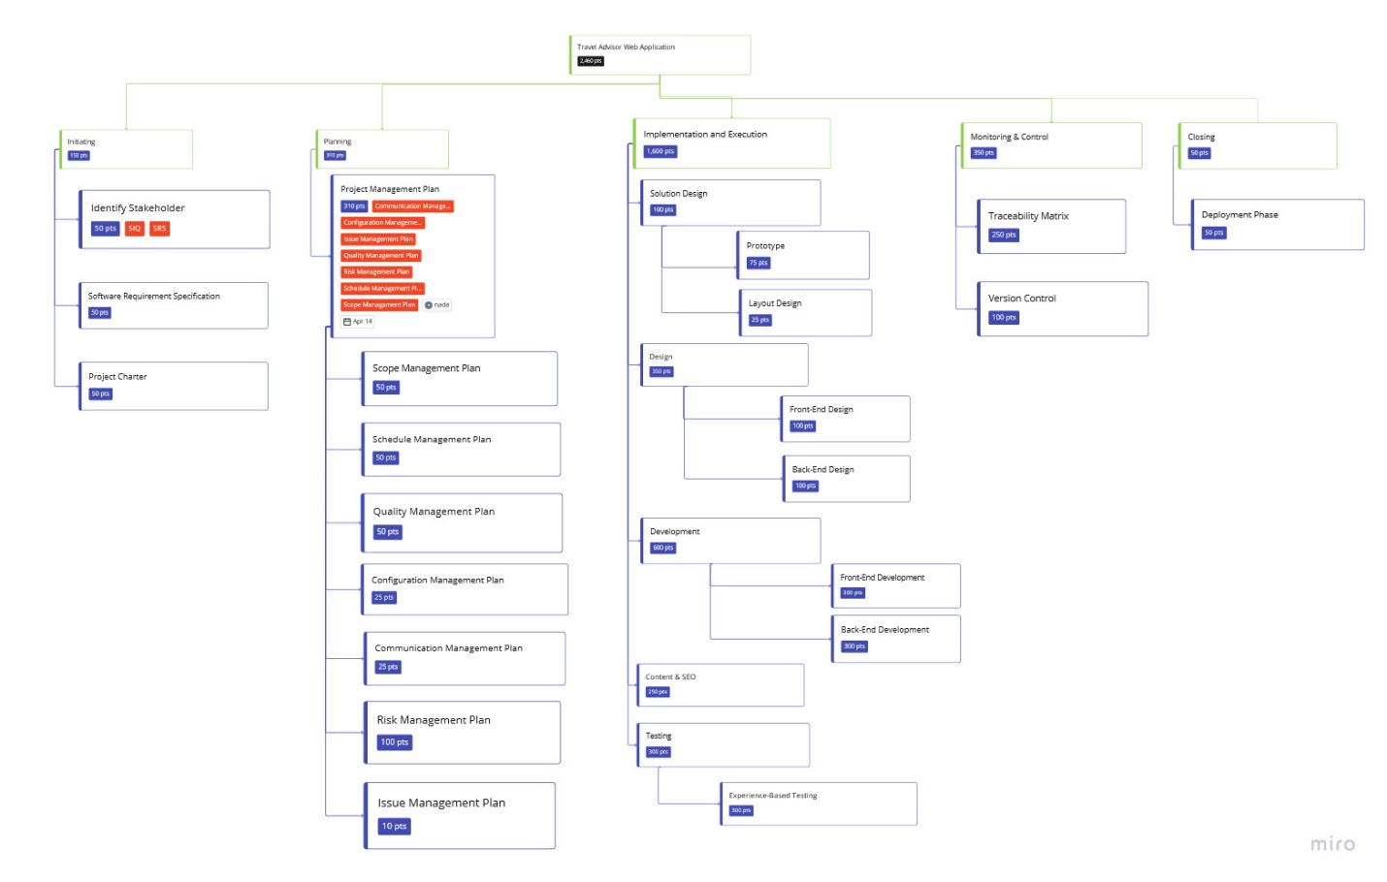

Figure WBS

The WBS Dictionary includes an entry for each WBS element. The project team will use the WBS Dictionary as a statement of work for each WBS element.

Table WBS Dictionary

|  |  |  |  |  |
| --- | --- | --- | --- | --- |
| Level | WBS Code | Element Name | Description of Work | Deliverables |
| 1 | 1.1 | Identify Stakeholder | Take CRS from client | N/A |
| 1 | 1.1.1 | Simple In Question | We collect our questions and inquiries from CRS to generate a formal SIQ | SIQ |
| 1 | 1.1.2 | Software Specification Requirement | We generate the user requirements and system requirements. | SRS |
| 1 | 1.2 | Project Charter | We make proposal for the customer. | Project Charter |
| 2 | 2.1 | Project Management Plan | We start the planning by creating the PMP. | PMP, SMP, STM, QMP, CMP, CMP, RMP |
| 2 | 2.1.1 | Scope Management Plan | From Project Charter, we developed SMP. | SMP, SMT |
| 2 | 2.1.2 | Schedule Management Plan | We marked the schedule of our project. | Milestones, PS,  Dependencies |
| 2 | 2.1.2.1 | Milestones | We insert the date for our first deliverables. | First Milestone |
| 2 | 2.1.2.2 | Project Schedule | We marked schedule for our project. | Gantt chart Schedule |
| 2 | 2.1.3 | Quality Management Plan |  |  |
| 2 | 2.4 | Configuration Management Plan | We choose our management of versions control of our releases | N/A |
| 2 | 2.1.5 | Communication Management Plan | We wrote our communication methods within our team and with the customer. | Communication Matrix |
| 2 | 2.1.5.1 | Communication Matrix | We stated our meetings in formal matrix. | N/A |
| 2 | 2.1.6 | Risk Management Plan | We generate the methods to handle risks while implementing the project. | RMP |
| 2 | 2.1.6.1 | Risk Log | We generate our risk log which is depend on risks we concern about, during planning our project. | RL |
| 3 | 3.1 | Solution Design | We created our simple prototype, and deliver the wireframe to make him imagine the design of our project. | Prototype,  Wireframe |
| 3 | 3.1.1 | Prototype | We create a small sample of our project. | Prototype |
| 3 | 3.1.2 | Layout Frame | We design our wireframe of our web application. | Wireframe |
| 3 | 3.2 | Design | We designed our web application. | BED, FED |
| 3 | 3.2.1 | Front-End Design | We start designing our layout. | Template of web app. |
| 3 | 3.2.2 | Back-End Design | We start designing our Backend layer. | Diagrams |
| 3 | 3.3 | Development | We start coding from this phase | FEL, BEL, ML |
| 3 | 3.3.1 | Front-End Development | We start implementing our FED | Front End layer |
| 3 | 3.3.2 | Back-End Development | We start implementing our BED | Back End Layer |
| 3 | 3.4 | Content and SEO | We insert content in the application. | Middle ware of web app |
| 3 | 3.5 | Testing | We test our web app. | TCW, BR |
| 3 | 3.5.1 | Experience-Based Testing | We test our web app using experience testers | TCR, BR |
| 4 | 4 | Monitoring and Control | We monitor our project from the initiation until the closing. | TRM |
| 4 | 4.1 | Traceability Matrix | We generate the trackability matrix from RMP and PMP | TRM |
| 4 | 4.2 | Version Control | We control our releases using git feature. | N/A |
| 5 | 5 | Closing | Here we finish our project creation. | Real Web App |
| 5 | 5.1 | Deployment Phase | We deployed our project and delivered it to the customer. | Travel Advisor Web Application |

# Scope Verification

As this project progresses the Project Manager will verify interim project deliverables against the original scope as defined in the scope statement, WBS and WBS Dictionary. Once the Project Manager verifies that the scope meets the requirements defined in the project plan, the Project Manager and Sponsor will meet for formal acceptance of the deliverable.

During this meeting the Project Manager will present the deliverable to the Project Sponsor for formal acceptance. The Project Sponsor will accept the deliverable by signing a project deliverable acceptance document. This will ensure that project work remains within the scope of the project on a consistent basis throughout the life of the project.

# Scope Control

The Project Manager and the project team will work together to control of the scope of the project. The project team will leverage the WBS Dictionary by using it as a statement of work for each WBS element. The project team will ensure that they perform only the work described in the WBS dictionary and generate the defined deliverables for each WBS element. The Project Manager will oversee the project team and the progression of the project to ensure that this scope control process if followed.

If a change to the project scope is needed the process for recommending changes to the scope of the project must be carried out. Any project team member or sponsor can request changes to the project scope. All change requests must be submitted to the Project Manager in the form of a project change request document. The Project Manager will then review the suggested change to the scope of the project. The Project Manager will then either deny the change request if it does not apply to the intent of the project or convene a change control meeting between the project team and Sponsor to review the change request further and perform an impact assessment of the change. If the change request receives initial approval by the Project Manager and Sponsor, the Project Manager will then formally submit the change request to the Change Control Board. If the Change Control Board approves the scope change the Project Sponsor will then formally accept the change by signing the project change control document. Upon acceptance of the scope change by the Change Control Board and Project Sponsor the Project Manager will update all project documents and communicate the scope change to all project team members stakeholders

# Sponsor Acceptance

Approved by the Project Sponsor:

Date:

<Project Sponsor>

<Project Sponsor Title>